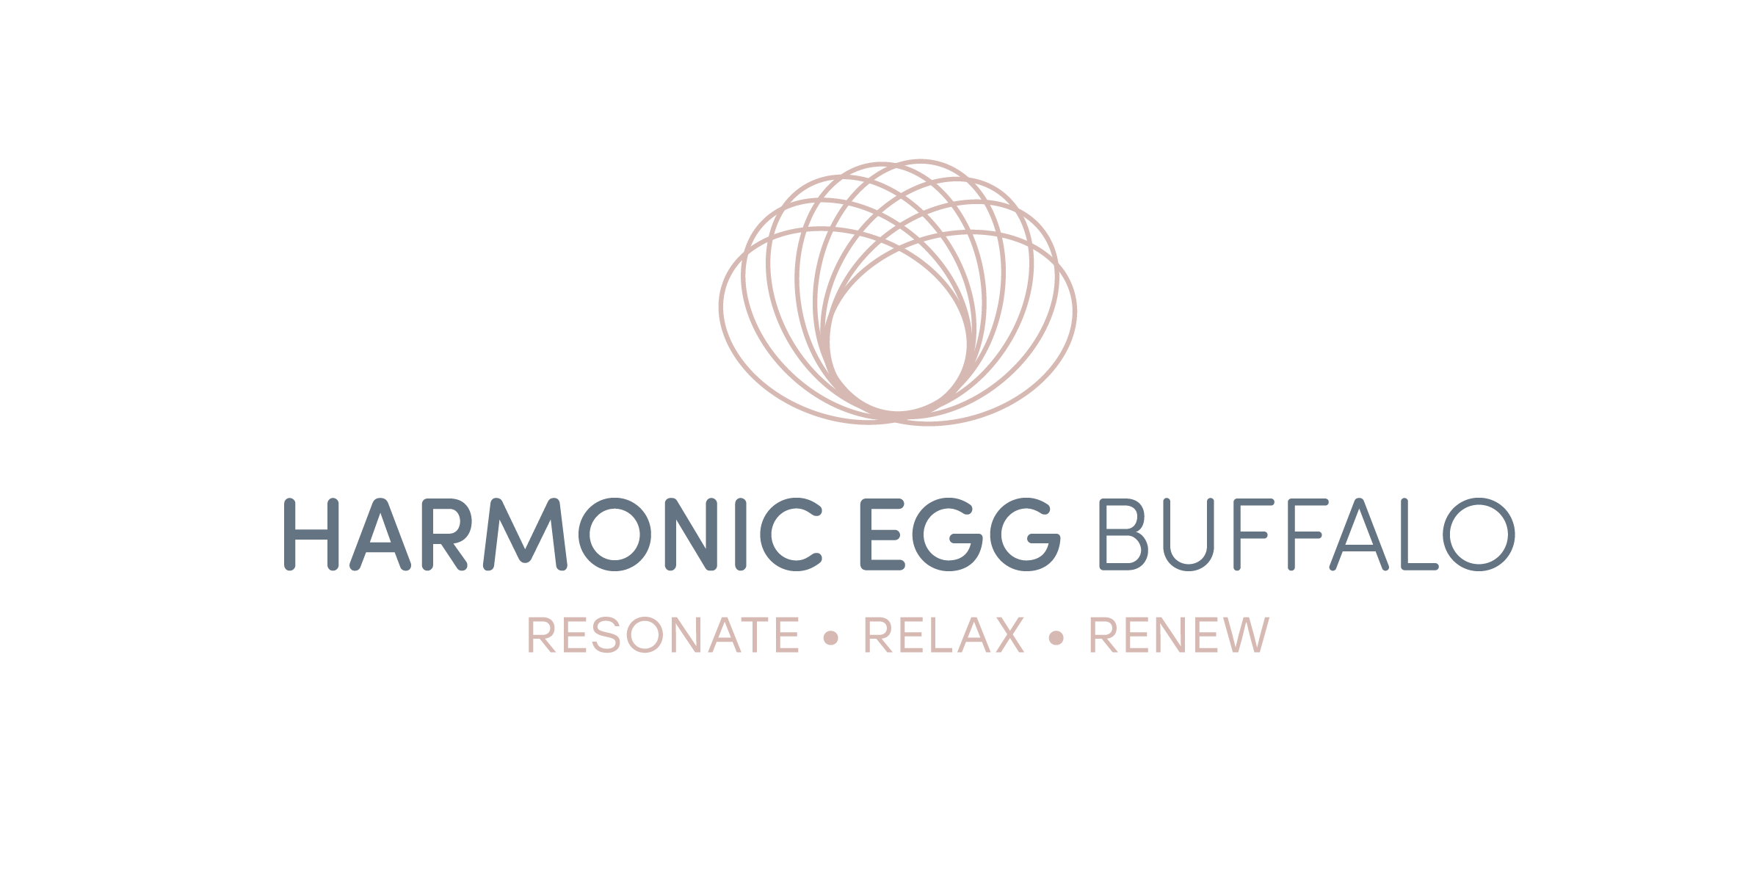
INFORMED CONSENT/CLIENT DECLARATION
I hereby voluntarily consent to a relaxation therapy session at Harmonic Egg Buffalo. I have read the program protocol and conditions and agree to comply with all recommendations, to the best of my ability, to receive maximum benefit.
I am responsible for the decision to seek this type of relaxation therapy program that could include improvement of the physical, psychological, emotional and environmental aspects of my illness. I recognize that the Harmonic Egg Buffalo Staff do not treat any specific disease or illness, and they are not licensed, certified, or registered by the state as a health care professional. However, all staff members are trained technicians and possess the proper training for administering sessions for clients. I recognize the possibility that this program may not prove successful or accomplish the results I expect or hope for. I understand that best results are obtained with a package program/protocol and membership.
I am fully informed that this approach to health differs from, and may not be recognized by, traditional medical standards. Clients should discuss any recommendations made by Harmonic Egg Buffalo with their medical professional. As further inducement to Harmonic Egg Buffalo to provide services for me, I hereby waive any claims and demands that I might now or hereafter have against Harmonic Egg Buffalo or its owners or staff that may arise, or deemed to arise from participating in therapy programs at Harmonic Egg Buffalo, and I hereby further release Harmonic Egg Buffalo and its owners and consultants from any and all liability of whatsoever kind or nature arising out of or in any way relating to the therapy sessions I will receive at Harmonic Egg Buffalo. Harmonic Egg Buffalo does carry liability insurance as deemed necessary by the State of New York and the leasing agent in which we are doing business on their property.
I understand that Harmonic Egg Buffalo reserves the right to deny treatment if it is not deemed by Harmonic Egg Buffalo to be in the best interest of the client(s) or staff.
It is understood that any therapy sessions, remedies, nutritional supplements, or treatment modalities are intended to enhance overall body performance and are not intended or implied to treat or “cure any specific illness.” It is understood that any suggestions regarding remedies and nutritional supplements are only Harmonic Egg Buffalo’s best recommendation and are at no time to be considered a prescription.

Date: ___________________________

Client Name (print): _______________________________

Signature: __________________________________

