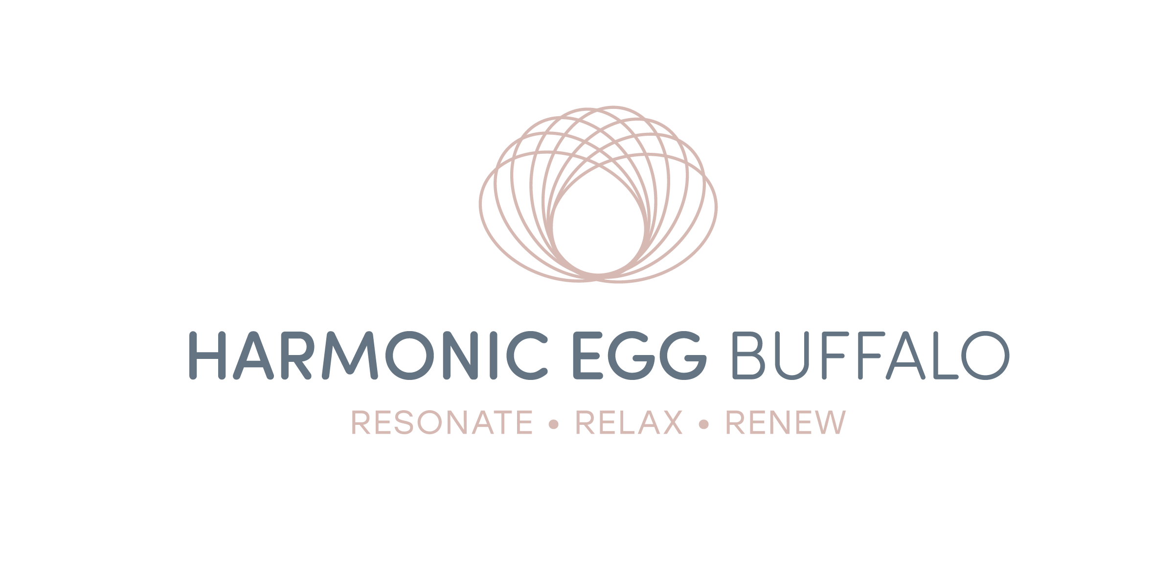
Protocol and Conditions
Plan to dress comfortably when visiting Harmonic Egg Buffalo. We also ask you to refrain from wearing any perfumes or colognes. All metal, including jewelry must be removed for the session. Pacemakers and implanted metal are permissible.
We suggest you be prepared to relax during your session. It’s totally normal to doze off, it doesn’t matter if your eyes are open or closed.
Your body will be integrating the energy for 5-7 days; use this time to restore and heal. Avoid strenuous exercise, getting blood work drawn and other energy work during this period. While you are in a detoxification process, your body has a limited amount of energy to take care of a lot of jobs. Your body will be cleaning house, fixing communication breakdowns and restructuring broken networks. Let your body rebuild and heal on its own, with its own energy.
It is very important to stay hydrated throughout your detoxification process (with every exhalation your body releases moisture). We cannot stress the water element strongly enough (60-90 ounces a day for 5-7 days after sessions is recommended). Hydration is critical to the process. To assist with hydration, we carry Superieur Electrolytes. It balances your electrolytes, gives you energy and assists your cells in absorbing water faster and more efficiently.
Avoid heavy foods (pastas, breads, cream sauces, greasy or fried foods), caffeine, alcohol and too much sugar…basically use your best judgment for a healthy lifestyle and diet. DO NOT FAST A light meal prior to your session is okay, you want the digestion process to be completed (30-60 minutes).
Cancellation Policy requires 24 hours notification, or you will be charged the session fee.
Thank you for understanding.
You acknowledge that Harmonic Egg Buffalo is not your primary care physician.
By signing this form, you the client, are agreeing to all the above.

X_______________________________________________ Date: ________________

Print Name: ___________________________ Phone: _____________

